What Is Infertility?

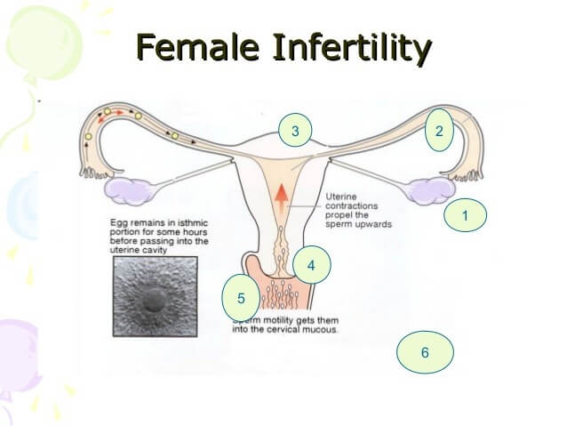

It is a disease in reproductive system, when people are not able to conceive normally is termed as in[fertility](https://www.mannatfertility.com/know-fertility/). This issue can be found both in male and female. In women infertility is termed if women are not able to carry full term pregnancy and in man who are not able to impregnate is termed as infertility.

Physiology

It’s very important to know the human principles of reproduction before investigating on [infertility](https://www.mannatfertility.com/).

Male Reproduction

The male system includes the testes wherever spermatozoon production happens at every seventy two days. The spermatozoon are carried by the epithelial duct and duct into the channel wherever ejaculation happens through the erectile organ. At the time of ejaculation, the valve into the bladder is closed, therefore inhibiting retrograde ejaculation into the bladder.

The seminal vesicles and endocrine contribute alimental fluid for the spermatozoon to measure in whereas within the ejaculate. It’s vital that the testes be slightly cooler than the other part of the body in order that effective gametogenesis will occur.

The Female Reproductive System

Female Reproductive System includes the duct wherever spermatozoon are deposited, the cervix wherever secretion is made that provides a reservoir for the ejaculated spermatozoon, the womb wherever the pregnancy progresses for 9 months, the fallopian tubes which offer a passage for spermatozoon and eggs, and therefore the ovaries within which biological process happens as a monthly development.

The pituitary glands and hypothalamus are extraordinarily vital for the occasion of eggs within the feminine and spermatozoon within the testicles. In each sex, the gonadotropin-releasing internal secretion is unrestricted in pulses from the hypothalamus at the bottom of the brain causation a message to the ductless gland (pituitary gland) to provide the hormones gonadotrophic hormone and LH.

In the ovary, the gonadotrophic hormone and LH offer a proof for the advance of eggs. As egg development happens, the inhibin and estrogen, made by the ovary, offer feedback to the pituitary and hypothalamus. This feedback grounds the assembly of gonadotrophic hormone and LH to decrease. Within the failing ovary, (premenopausal) estrogen and inhibin levels are low as the feedback is inhibited and gonadotrophic hormone and LH levels are also high, signifying impending female internal reproductive organ failure.

In the male, FSH and LH action on the testicles to enable the spermatozoon production. Again, there’s a response loop through the pituitary and neural structure via the internal secretion androgen.

The hypothalamus is an especially sensitive a chunk of the human brain, chiefly in females. Changes in diet, exercise, excessive weight gain or loss, extreme stress, emotional disturbance and even changes within the light/dark cycles could alter its perform. These changes have an effect on the GnRH pulses and therefore pituitary performs with change within the excretion of the hormones FSH and LH.

These variations have an effect on gonad perform with modifications within the production of sex hormone, that prepares the female internal reproductive organ to just an embryo and Lipo-Lutin. The internal secretion of the phase, that is vital in maintaining a gestation. Internal secretion(Thyroid hormone) balance is additionally very vital to the general functioning of this technique.

Because of the secretion changes mentioned on top of, a feminine experiences a monthly cycle. Within the half of the cycle, (proliferate phase), the liner of the female internal reproductive organ is advanced so an embryo will implant. The latter half of the cycle is considered by the excretion of Lipo-Lutin (secretory phase) to keep up the liner of the female internal reproductive organ.

Ovulation is that the event that happens between the proliferative and secretory stages, and is sometimes the middle cycle. At the tip of the phase (which typically lasts fourteen days), periods (peeling of the liner of the uterus) happens if theres no gestation.

The secretion events in an exceedingly traditional cycle and are very complicated. Gonadotropin is secreted from the pituitary inflicting the ovaries to supply oestrogen. Simply before the biological process, the secretion gonadotrophic hormone is discharged from the pituitary, triggering and ovulatory response within the ovary. (This could be a secretion measured in biological process prediction kits and is within the bloodstream for a brief time).

After the biological process, a progestogen is veiled by the ductless gland(corpus luteum) of the ovary and functions to keep up a gestation.

If spermatozoa are placed within the womb at the period of ovulation, they whirl into the fallopian tubes to encounter an egg that has been discharged from the ovary. The spermatozoon enters the egg (fertilization) and such a combination of a spermatozoon and egg forms a fertilized ovum. This is often the start of life.